
Solution Architecture

Date

27

June

2026

T
eam

ID

SWTID-2026-2944

Pr
oject

Name

Smart Lender

Maximum

Marks

5

Marks

Solution Architecture Diagram:
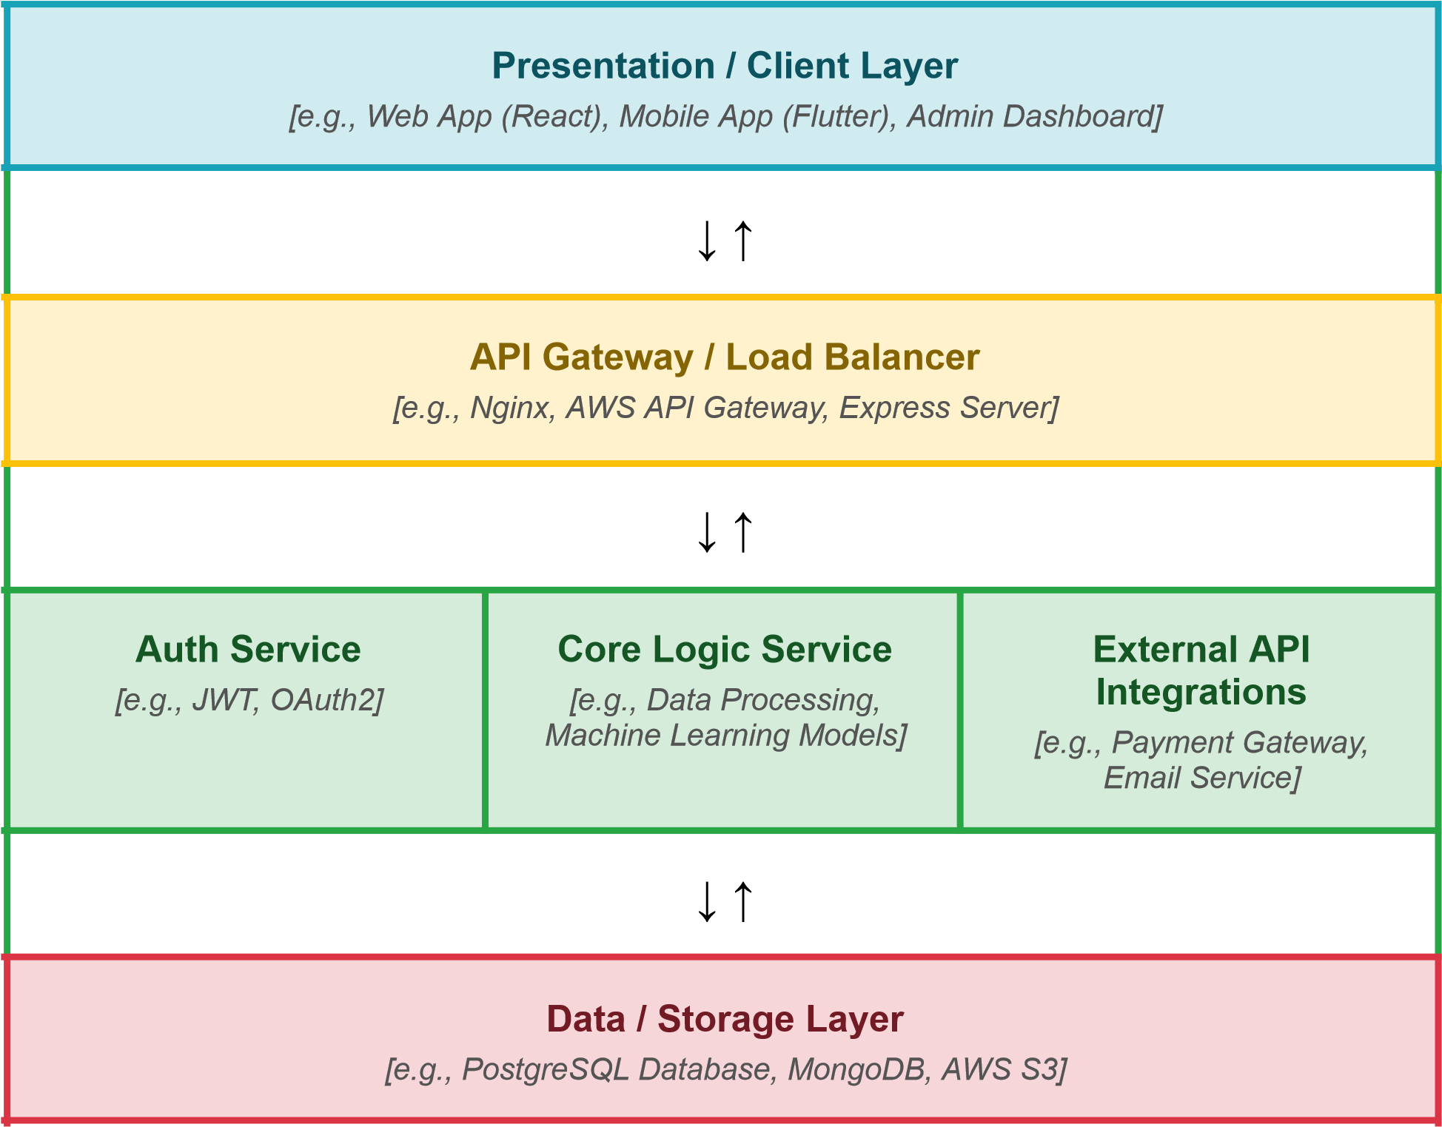
Provide a high-level visual representation of your solution's architecture. Use the structural layout below as a template to map out your Presentation Layer, Application Layer, and Data Layer. Fill in the specific technologies and components for your project directly into the boxes to create your architectural diagram.



Component Description Table

Component Name | Description / Role in Architecture | Technologies Used
*Presentation Layer* | Serves as the user interface for borrowers to apply for loans, upload documents, and check application status. It also includes an Admin/Loan Officer dashboard to review, approve, or reject applications. | React.js, Flutter, HTML5/CSS3
*API Gateway* | Acts as the single entry point for all client requests. | AWS API Gateway, Nginx
*Microservices* | *Auth Service*: Manages user authentication and secure access. | Node.js, Python (FastAPI/Flask for ML models), JWT, OAuth2, Stripe/Razorpay

